Infrastructure Document

For

AWS Eros Infra for E-commerce Website

Document Control Sheet
Client Name | Eros
Project Code | Magento
Current Version | 0.2
Document Type | Proposal Document
Author | Rohit
Sales Person
Reviewed by | Mayur
Frequency of Document Review | First Standard Document
Document Creation Date | Wednesday, Sept 8, 2021
Document Last Updated | Tuesday, Apr 8, 2022

Revision History
Version | Date | Name | Comment / Revision
1.0 | 9/8/21 | Rohit | Infrastructure Management Support
2.0 | 9/14/21 | Rohit | Estimation for 1000-2000 concurrent users

Contents
Document Control Sheet 1
Revision History 1
Client requirement 3
Service Level Requirements: 3
Management: 3
Amazon Virtual Private Cloud VPC 3
AWS EC2 Instance 4
An EC2 instance is a virtual server in Amazon Web services terminology. It is a web service where an AWS subscriber can request and provision a compute server in AWS cloud. 4
Security Groups 5
Application Load Balancer 5
Amazon RDS 6
Amazon RDS makes it easy operate, and scale a relational database in the cloud. It provides cost-efficient and resizable capacity while automating time-consuming administration tasks such as hardware provisioning, database setup, patching and backups. It frees you to focus on your applications so you can give them the fast performance, high availability, security and compatibility they need. 6
Architecture Diagram: 7
Amazon Route 53: 7
Amazon ACM: 8
Patches And Upgrades 8
AWS Systems Manager Patch Manager 8
Why Us 9
Numbers tells the clear picture 10
Industries served 10
Certifications 11

Client requirement
EROS is a E-commerce shopping platform currently available for the customers from Dubai. Designed for the future for digital and small screens. All the requirements and needy things in day to day life of peoples can easily they find in this site.
On a single search & a click anything can get on a single page, in a very quick manner. customers satisfaction is a first priority for us. & will always follow the words
Client wants a Justification on the proposed Server Architecture and the Server Capacity Planning on AWS Cloud and the respective Architecture diagram, Security Administration and Control.

Service Level Requirements:
- Availability
- Scalability
- Reliability
- Security
- Performance
- Efficient Database system
- Minimal Upfront Cost

Management:

Amazon Virtual Private Cloud VPC
Amazon VPC is the networking layer for Amazon EC2. virtual private network that keeps your servers safe from the ravages of the public internet.
The following are the key concepts for VPCs:
- Virtual private cloud (VPC) — A virtual network dedicated to your AWS account. We have created VPC for our infrastructure in “Middle East (Bahrain) me-south-1“ location, with the 10.0.0.0/16 IPv4 CIDR.
- Subnet — It is a range of IP addresses in your VPC. We created seven subnets including Dev and Stage environment i.e., three public subnet and four private subnets. Each subnet available approx. 250 IPv4 addresses. The use of this subnets is to configure load balancer in our private instances.
- Route table — A set of rules, called routes, that are used to determine where network traffic is directed. We created four route tables i.e., main route tables are for public subnet association and private route tables are for private subnet association.
- Internet gateway — A gateway that you attach to your VPC to enable communication between resources in your VPC and the internet. In our Infrastructure we have created “ITS-Bahrain-Eros-Prod-IGW” internet gateway and attached to “ITS-Bahrain-Eros-Prod” VPC.
- NAT gateway -- Network Address Translation (NAT) Gateway, a highly available AWS managed service that makes it easy to connect to the Internet from instances within a private subnet in an AWS Virtual Private Cloud (VPC).

AWS EC2 Instance

An EC2 instance is a virtual server in Amazon Web services terminology. It is a web service where an AWS subscriber can request and provision a compute server in AWS cloud.
In our Aws Infrastructure, there are six EC2 instances are running.

- EROS-bastion-Prod-EC2 t3.medium Instance
- EROS-Magento-Prod-EC2 m5.2x Large Instance
- EROS-ES-Prod-EC2 m5.xlarge Instance
- EROS-Redis-Prod-EC2 t3 large Instance
- EROS-Magento-Dev-EC2 t3.xlarge Instance
- EROS-Magento-Dev-EC2 t3.xlarge Instance

For Static IP, which does not change IP addresses over time. We configure AWS Elastic IP addresses to the jump servers and the NAT gateway.

Security Groups
A security group acts as a virtual firewall for your EC2 instances to control incoming and outgoing traffic. Inbound rules control the incoming traffic to your instance, and outbound rules control the outgoing traffic from your instance. When you launch an instance, you can specify one or more security groups.

Application Load Balancer
Elastic Load Balancing automatically distributes your incoming traffic across multiple targets, such as EC2 instances, containers, and IP addresses, in one or more Availability Zones. It monitors the health of its registered targets, and routes traffic only to the healthy targets. Elastic Load Balancing scales your load balancer as your incoming traffic changes over time. It can automatically scale to the vast majority of workloads. The load balancer distributes incoming application traffic across multiple targets, such as EC2 instances, in multiple Availability Zones. This increases the availability of your application. We can add one or more listeners to load balancer.
For this we have to create one load balancer, also there is different target groups and listeners. We created two target groups for production and Staging application load balancer and attached.
- In Prod ALB we added host listener i.e., www.eros.ae with the rule of redirecting to HTTPS.

Amazon RDS

Amazon RDS makes it easy operate, and scale a relational database in the cloud. It provides cost-efficient and resizable capacity while automating time-consuming administration tasks such as hardware provisioning, database setup, patching and backups. It frees you to focus on your applications so you can give them the fast performance, high availability, security and compatibility they need.
In Our AWS infrastructure, there are two Databases
- Eros-prod-rds-mysql
- Eros-devstage-rds-mysql

In Production database, we configure below details:
- Taken a Burstable classes DB instance – db.t3.medium.
- Allocate 100 GiB of storage of General-purpose storage type.
- Configure RDS security group with the inbound rules of 3306 port.
- Created parameter group, parameter group acts as a container for engine configuration values.
- Enable deletion protection

In DevStage database, we configure below details:
- Taken a Burstable classes DB instance – db.t3.medium.
- Allocate 100 GiB of storage of General-purpose storage type.
- Configure RDS security group with the inbound rules of 3306 port.
- Created parameter group, parameter group acts as a container for engine configuration values.
- Enable deletion protection

Architecture Diagram:
Cloud Architecture Diagram of Eros-Magento Architecture:
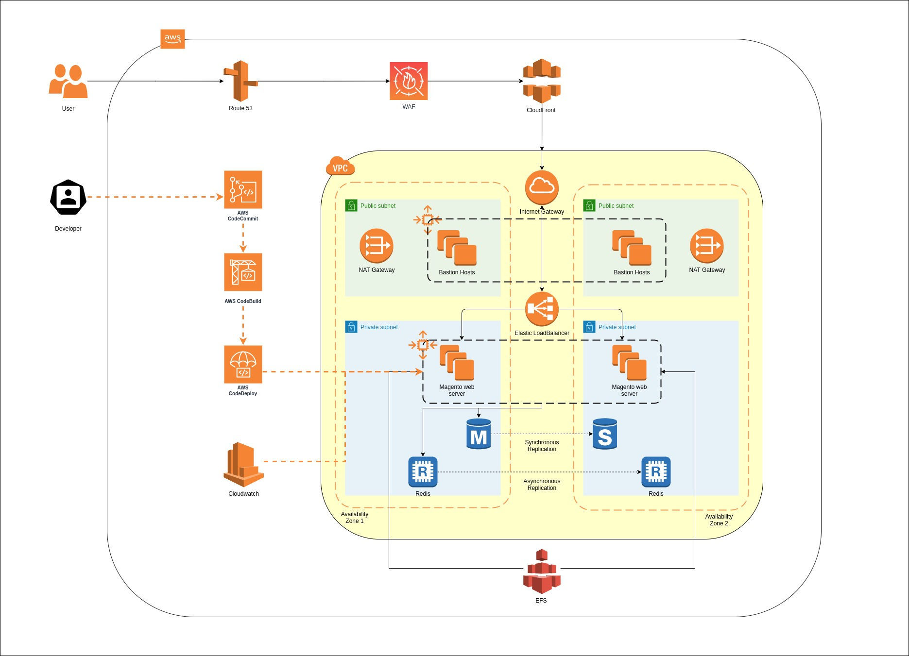

Amazon Route 53:
Amazon Route 53 effectively connects user requests to infrastructure running in AWS – such as Amazon EC2 instances, Elastic Load Balancing load balancers and can also be used to route users to infrastructure outside of AWS. We have one DNS hosted zone for eros with the name of eros.ae. As the domain eros.ae was purchased from other domain provider so We transfer domain to route 53 by replacing nameserver.

Amazon ACM:
AWS Certificate Manager (ACM) handles the complexity of creating, storing, and renewing public and private SSL/TLS X.509 certificates and keys that protect your AWS websites and applications. We requested a public certificate from amazon for our domain. We issued multiple SSL certification from ACM, domain we register with SSL are as Follow:
- *.eros.ae
- www.eros.ae
- dev.eros.ae
- staging,eros.ae

Patches And Upgrades

AWS Systems Manager Patch Manager
Patch Manager, a capability of AWS Systems Manager, automates the process of patching managed instances with both security related and other types of updates. We can use Patch Manager to apply patches for both operating systems and applications. (On Windows Server, application support is limited to updates for Microsoft applications.) We can use Patch Manager to install Service Packs on Windows
instances and perform minor version upgrades on Linux instances. You can patch fleets of Amazon Elastic Compute Cloud (Amazon EC2) instances or your on-premises servers and virtual machines (VMs) by operating system type. This includes supported versions of Amazon Linux, Amazon Linux 2, CentOS, Debian Server, macOS, Oracle Linux, Red Hat Enterprise Linux (RHEL), SUSE Linux Enterprise Server (SLES), Ubuntu Server, and Windows Server. You can scan instances to see only a report of missing patches, or you can scan and automatically install all missing patches.
Patch Manager uses patch baselines, which include rules for auto-approving patches within days of their release, as well as a list of approved and rejected patches. You can install patches on a regular basis by scheduling patching to run as a Systems manager maintenance window task. You can also install patches individually or to large groups of instances by using Amazon EC2 tags. (Tags are keys that help identify and sort your resources within your organization.) You can add tags to your patch baselines themselves when you create or update them.
Patch Manager integrates with AWS Identity and Access Management (IAM), AWS CloudTrail, and Amazon EventBridge to provide a secure patching experience that includes event notifications and the ability to audit usage.

Why Us
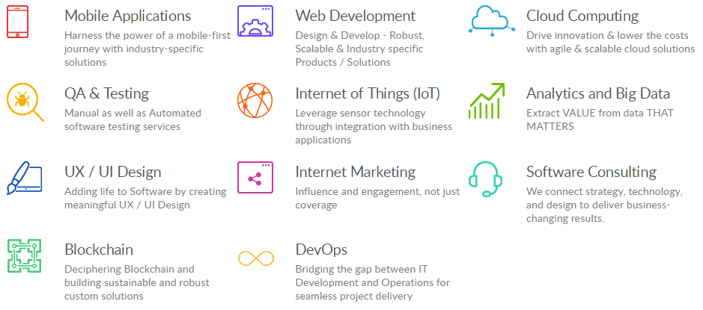
A Wide Range of Services

Numbers tells the clear picture
5500+  Websites | 750+  Mobile Apps | 1500+  Employees | 1500+  Customers

Industries served

  Banking and Finance |   Ecommerce & Retail |   Education & E-learning
  Government |   Health care |   Insurance
  IT & Consulting |   Manufacturing |   Media & Entertainment
  News & Publication |   Startup |   Telecom

Certifications
